# ASSIGNMENT 3 Bucket And Watson assistant

|  |  |
| --- | --- |
| StudentName | RAJESH C R |
| StudentRollNumber | 73771914156 |

**Questions:**

# Create a Bucket in IBM object storage.

1. **Upload an 5 images to ibm objects to range and make it public. Write html code to displaying all the 5images.**
2. **Upload access page to the objects to range and use the same page in your HTML code.**

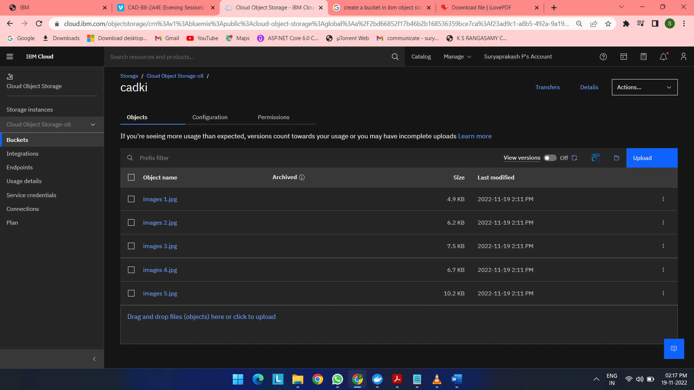

# Index.html

<!DOCTYPEhtml>

<htmllang="en">

<head>

  <metacharset="UTF-8">

  <metahttp-equiv="X-UA-Compatible"content="IE=edge">

  <metaname="viewport"content="width=device-width, initial-scale=1.0">

  <title>Home page</title>

  <!-- bootstrap csscdn -->

  <linkrel="stylesheet"href="https://stackpath.bootstrapcdn.com/bootstrap/4.5.2/css/bootstrap.min.css"

    integrity="sha384-JcKb8q3iqJ61gNV9KGb8thSsNjpSL0n8PARn9HuZOnIxN0hoP+VmmDGMN5t9UJ0Z"crossorigin="anonymous">

  <linkrel="stylesheet"href="https://cdnjs.cloudflare.com/ajax/libs/font-awesome/4.7.0/css/font-awesome.css">

  <!--css stylesheet -->

  <linkrel="stylesheet"href="/static/css/style.css">

  <!-- font styles cdn -->

  <linkrel="preconnect"href="https://fonts.gstatic.com">

  <linkhref="https://fonts.googleapis.com/css2?family=Alegreya&display=swap"rel="stylesheet">

  <linkhref="https://fonts.googleapis.com/css2?family=Alegreya:wght@600&display=swap"rel="stylesheet">

</head>

<body>

  <H1>WELCOME TO HOME PAGE</H1>

  <imgsrc="https://cadki.s3.jp-tok.cloud-object-storage.appdomain.cloud/images%201.jpg"alt="img">

  <imgsrc="https://cadki.s3.jp-tok.cloud-object-storage.appdomain.cloud/images%202.jpg"alt="img">

  <imgsrc="https://cadki.s3.jp-tok.cloud-object-storage.appdomain.cloud/images%203.jpg"alt="img">

  <imgsrc="https://cadki.s3.jp-tok.cloud-object-storage.appdomain.cloud/images%204.jpg"alt="img">

  <imgsrc="https://cadki.s3.jp-tok.cloud-object-storage.appdomain.cloud/images%205.jpg"alt="img">

</body>

</html>

**OUTPUT:**

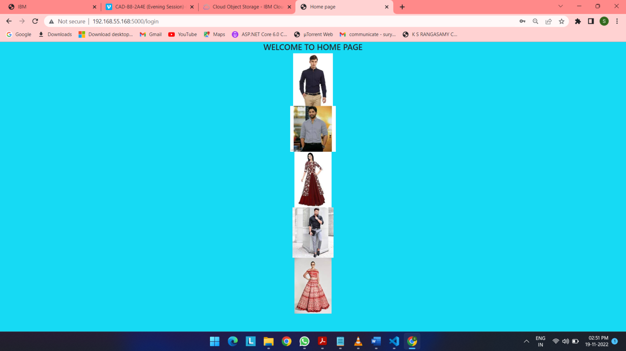

1. **Design a chatbot using IBM Watson assistant for hospital. Ex:Usercomes with query to know the branches for that hospital in your city. Submit the web URL of that chat bot as assignment.**

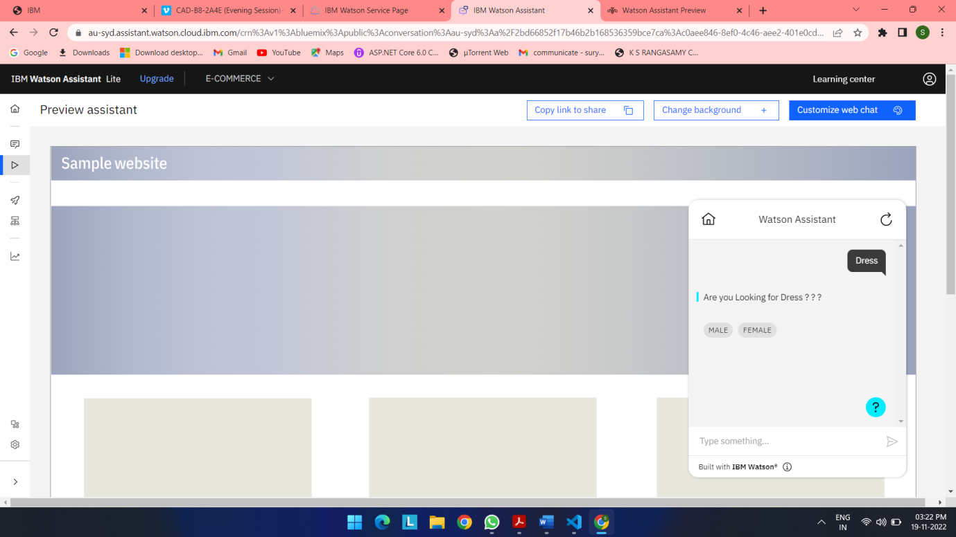

**URL LINK**: <https://web-chat.global.assistant.watson.appdomain.cloud/preview.html?backgroundImageURL=https%3A%2F%2Fau-syd.assistant.watson.cloud.ibm.com%2Fpublic%2Fimages%2Fupx-c0aee846-8ef0-4c46-aee2-401e0cdebd96%3A%3Acef1356b-10da-4cea-b428-7ea51a2f68e6&integrationID=02ee2436-04f1-4a28-8302-a5a1e783455b&region=au-syd&serviceInstanceID=c0aee846-8ef0-4c46-aee2-401e0cdebd96>

**HTML CODE:**

<!DOCTYPEhtml>

<htmllang="en">

<head>

  <metacharset="UTF-8">

  <metahttp-equiv="X-UA-Compatible"content="IE=edge">

  <metaname="viewport"content="width=device-width, initial-scale=1.0">

  <title>Home page</title>

  <!-- bootstrap csscdn -->

  <linkrel="stylesheet"href="https://stackpath.bootstrapcdn.com/bootstrap/4.5.2/css/bootstrap.min.css"

    integrity="sha384-JcKb8q3iqJ61gNV9KGb8thSsNjpSL0n8PARn9HuZOnIxN0hoP+VmmDGMN5t9UJ0Z"crossorigin="anonymous">

  <linkrel="stylesheet"href="https://cdnjs.cloudflare.com/ajax/libs/font-awesome/4.7.0/css/font-awesome.css">

  <!--css stylesheet -->

  <linkrel="stylesheet"href="/static/css/style.css">

  <!-- font styles cdn -->

  <linkrel="preconnect"href="https://fonts.gstatic.com">

  <linkhref="https://fonts.googleapis.com/css2?family=Alegreya&display=swap"rel="stylesheet">

  <linkhref="https://fonts.googleapis.com/css2?family=Alegreya:wght@600&display=swap"rel="stylesheet">

</head>

<body>

  <H1>WELCOME TO HOME PAGE</H1>

  <divclass="obj">

  <imgsrc="https://cadki.s3.jp-tok.cloud-object-storage.appdomain.cloud/images%201.jpg"alt="img">

  <imgsrc="https://cadki.s3.jp-tok.cloud-object-storage.appdomain.cloud/images%202.jpg"alt="img">

  <imgsrc="https://cadki.s3.jp-tok.cloud-object-storage.appdomain.cloud/images%203.jpg"alt="img">

  <imgsrc="https://cadki.s3.jp-tok.cloud-object-storage.appdomain.cloud/images%204.jpg"alt="img">

  <imgsrc="https://cadki.s3.jp-tok.cloud-object-storage.appdomain.cloud/images%205.jpg"alt="img">

</div>

<script>

  window.watsonAssistantChatOptions = {

    integrationID:"02ee2436-04f1-4a28-8302-a5a1e783455b", // The ID of this integration.

    region:"au-syd", // The region your integration is hosted in.

    serviceInstanceID:"c0aee846-8ef0-4c46-aee2-401e0cdebd96", // The ID of your service instance.

    onLoad:function(instance) { instance.render(); }

  };

  setTimeout(function(){

    constt=document.createElement('script');

    t.src="https://web-chat.global.assistant.watson.appdomain.cloud/versions/" + (window.watsonAssistantChatOptions.clientVersion || 'latest') + "/WatsonAssistantChatEntry.js";

    document.head.appendChild(t);

  });

</script>

</body>

</html>

**OUTPUT:**

